Pre-Diagnosis Email Instructions

Please use the following steps to create an email to share with your clients.
Step 1:
Copy and paste the subject line below into an email.
Feline Osteoarthritis (OA) Pain: Recognizing the Signs

Step 2:
Follow the instructions on the next page to customize your email.

Step 3:
Add the following links below the corresponding images with the email:
www.CatOAPainChecklist.com
www.VetVisitTipsandTricks.com
www.SolensiaPI.com

Step 4:
That’s it! Send the email off to your customers to help them track their cat's progress on Solensia and better prepare for their next visit.

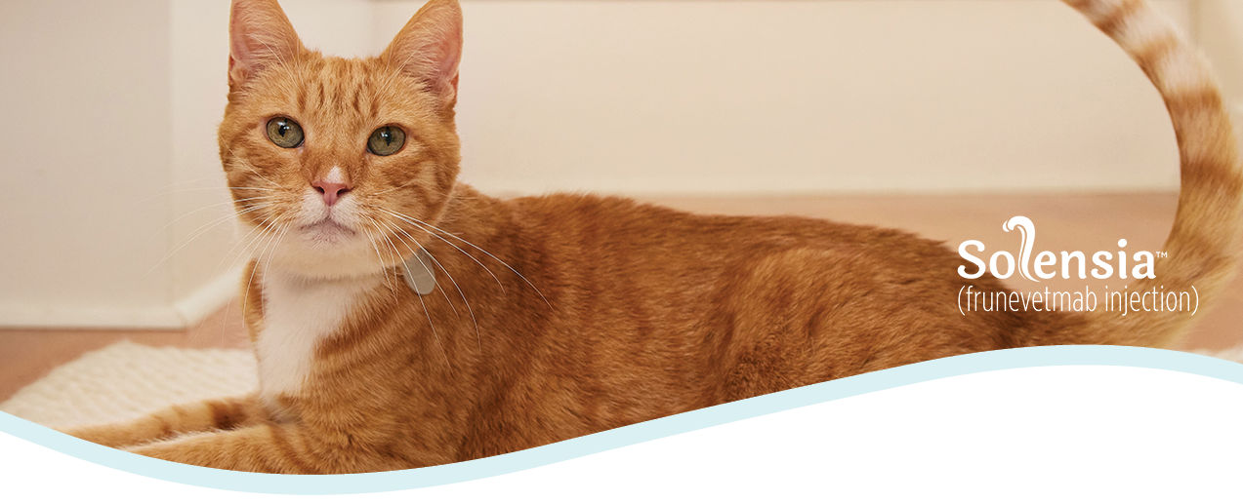
Copy and paste Image 1
Insert your personal introduction, as well as any pet owner salutations here.
Copy and paste Image 2
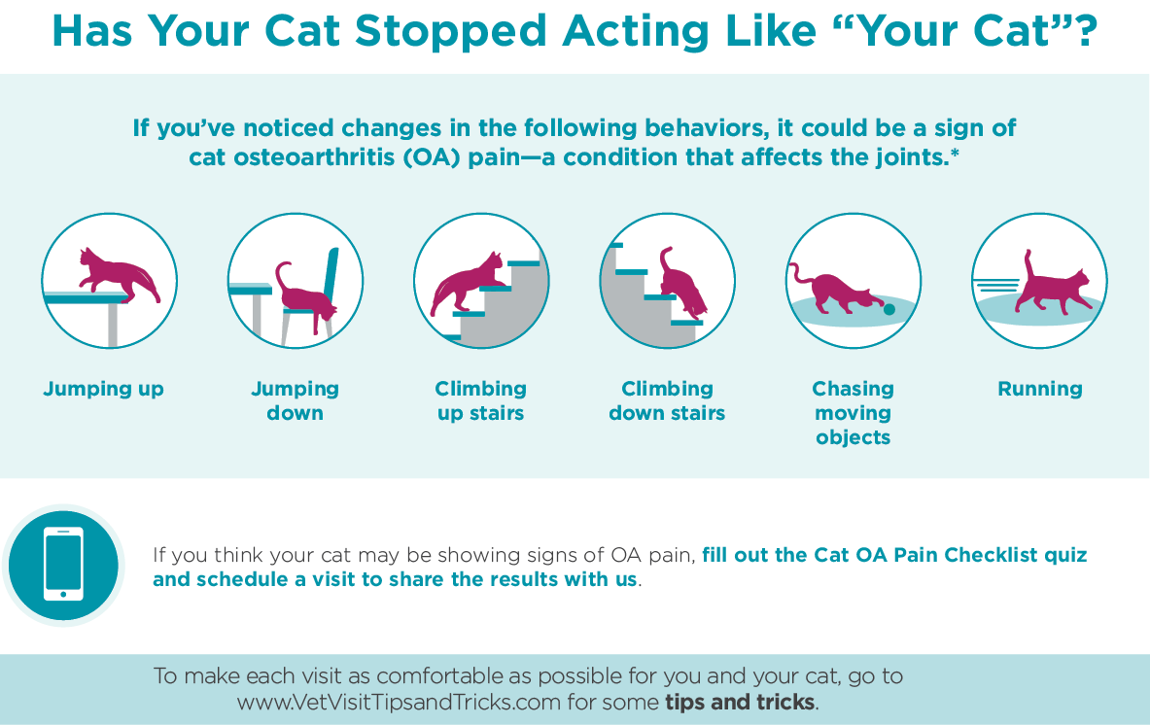
Insert your clinic’s contact information (website, phone number, etc) along with any scheduling reminders/information.

Copy and paste Image 3

